TALTON HOUSE & COURTYARD & POOLHOUSE ACCOMM 2024-25
 | GUEST NAME:  ADDRESS:  PHONE NUMBER: |  | Arrival date:  Departure date:
 | ROOM NAME | BEDS MADE UP AS… | NUMBER OF ADULTS per room
 | FIRST FLOOR
 | Dr Watson  Private bathroom  Sleeps 2 | SUPER KING or TWIN | 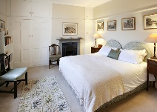
 | CHRISTABEL CARLISLE  ensuite  sleeps up to 3 | SUPER KING and DBLE SOFA BED  (sofa bed for 1 adult/2 kids) | 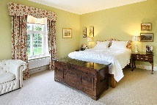
 | GEORGE FARRAR  ensuite shower/toilet  sleeps 2 | TWIN ( 1 or 2 singles ) | 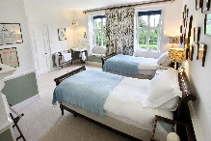
 | GWEN FARRAR  Ensuite  Sleeps up to 4 | SUPER KING and up to 2 optional Z BEDS | 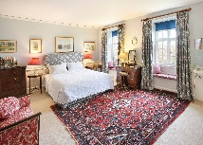
 | MORICE BIRD  Shared bathroom  Sleeps 1 | SINGLE | 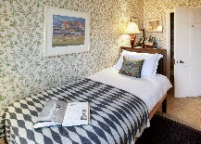
 | ELLA FARRAR  Shared bathroom  Sleeps 2 | TWIN - 1 or 2 beds | 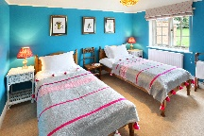
 | LADY ABERCONWAY  Shared bathroom  Sleeps 2 | SUPERKING orTWIN | 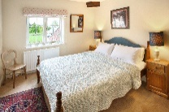
 | Anne McLaren  Shared bathroom  Sleeps up to 4 | SUPERKING plus 1 or 2 SINGLES /  OR 4 SINGLES | 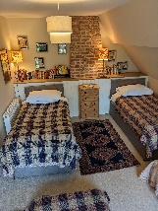
 | GROUND FLOOR | Wheel chair access with accessible shower and loo.
 | GUN ROOM  accessble ensuite  Bedroom or cloakroom  Sleeps 2 | SUPER KING or TWIN or  SINGLE | 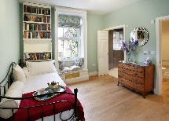
 | COURTYARD EXTRA £300 per 3N W/E or as per quote. | please do not allocate unless paid for. | PLEASE SPECIFY YOUR REQUIREMENTS AND NUMBER OF ADULTS
 | Extra Dble/Twin  In courtyard by house. Ensuite  Sleeps up to 2 | SUPERKING OR TWIN with ensuite shower room WC and private entrance | 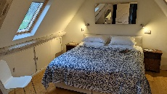
POOL HOUSE EXTRA £380 per 3N W/E or per quote. |  | please do not allocate unless paid for. BEDS MADE UP AS… | PLEASE SPECIFY YOUR REQUIREMENTS AND NUMBER OF ADULTS
Extra Dble/+ sofa bed small double  In Orchard by pool.  King Dble on mezz  Open plan living room, kitchenette, with pocket sprg Dble sofa bed.  Bathroom (shower).  Has its own terrace. Sleeps up to 4. |  | King DOUBLE on mezzanine and specify 1 SINGLES or extra DOUBLE downstairs | 