TALTON HOUSE & COURTYARD ACCOMMODATION
GUEST NAME:  ADDRESS:  PHONE NUMBER: |  |  | Arrival date:  Departure date:
ROOM NAME | BEDS MADE UP AS… | NUMBER OF ADULTS per room
FIRST FLOOR
Dr Watson  Private bathroom  Sleeps 2 | SUPER KING or 1 or 2 singles | 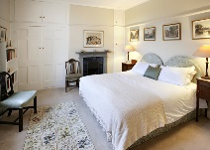
CHRISTABEL CARLISLE  ensuite  sleeps up to 3 | SUPER KING and DBLE SOFA BED  (sofa bed for 1 adult) | 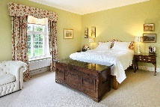
GEORGE FARRAR  ensuite shower/toilet  sleeps 2 | TWIN ( 1 or 2 singles ) | 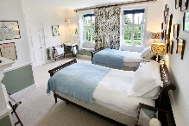
GWEN FARRAR  Ensuite  Sleeps up to 4 | SUPER KING and up to 2 optional Z BEDS | 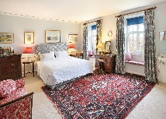
MORICE BIRD  Shared bathroom  Sleeps 1 | SINGLE | 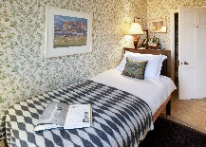
ELLA FARRAR  Shared bathroom  Sleeps 2 | TWIN - 1 or 2 beds | 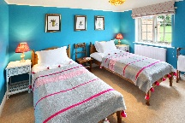
LADY ABERCONWAY  Shared bathroom  Sleeps 2 | KING | 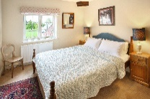
Anne McLaren  Shared bathroom  Sleeps up to 4 | SUPERKING plus 1 or 2 SINGLES /  OR 4 SINGLES | 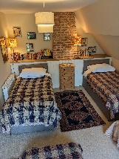
GROUND FLOOR | Wheel chair access with accessible shower and loo.
GUN ROOM  accessble ensuite  Bedroom or cloakroom  Sleeps 2 | SUPER KING or 1 or  2 SINGLES | 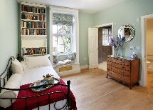
COURTYARD | £240 extra- please do not allocate unless you paid for it
Extra Dble/Twin  In courtyard by house. Ensuite  Sleeps up to 2 | TWIN OR DOUBLE with shower room WC and private entrance | 